**Hands on 1**

**Create a Spring Web Project using Maven** 

**OUTPUT:-**

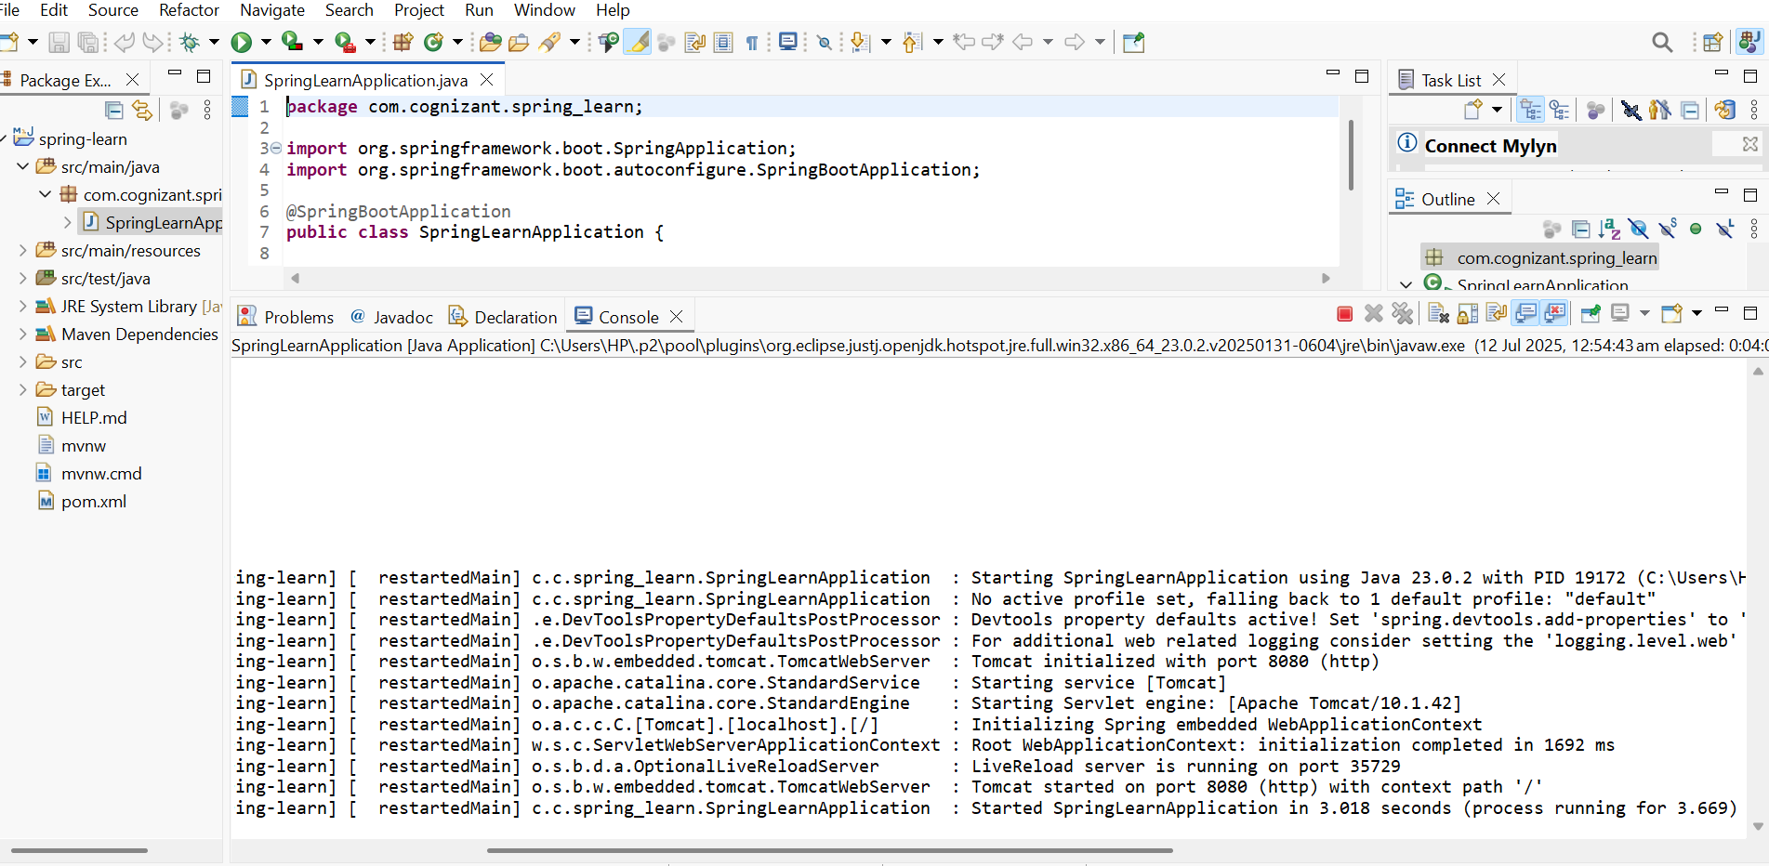

**Project Structure to Understand**

| **Path** | **Purpose** |
| --- | --- |
| src/main/java | Your main application code goes here |
| src/main/resources | Configuration files (e.g., application.properties) |
| src/test/java | Test cases go here |
| SpringLearnApplication.java | Main class with main() method |
| @SpringBootApplication | Starts your Spring Boot app (combines config, scan, etc.) |
| pom.xml | Project's dependency and build config |